ADVANCE SOFTWARE ENGINEERGING

ASSINGMENT -5

We have created sign in page using google credentials. After successful the login the user will be

Redirected to the next page.

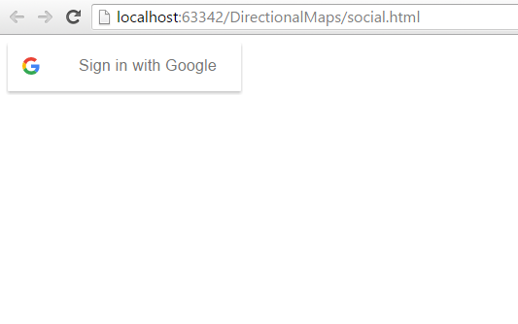

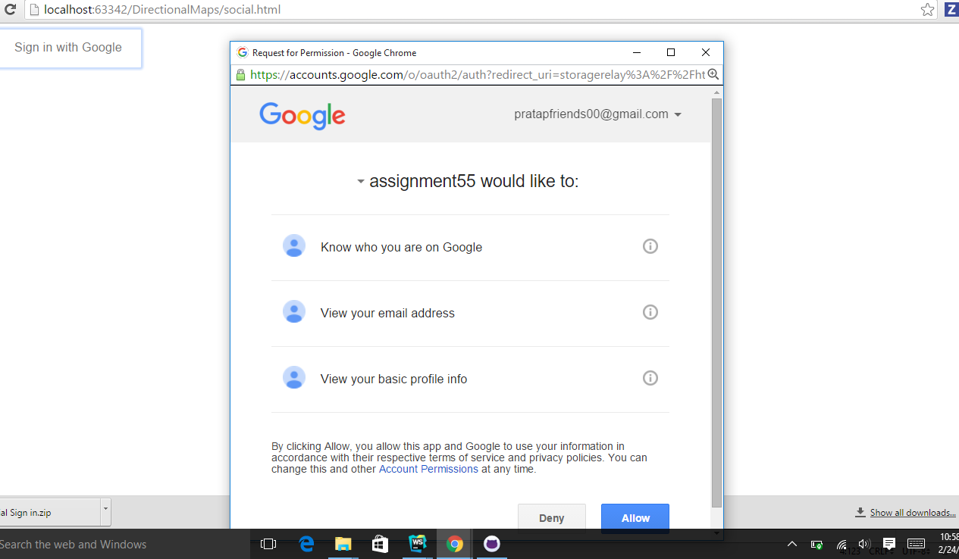

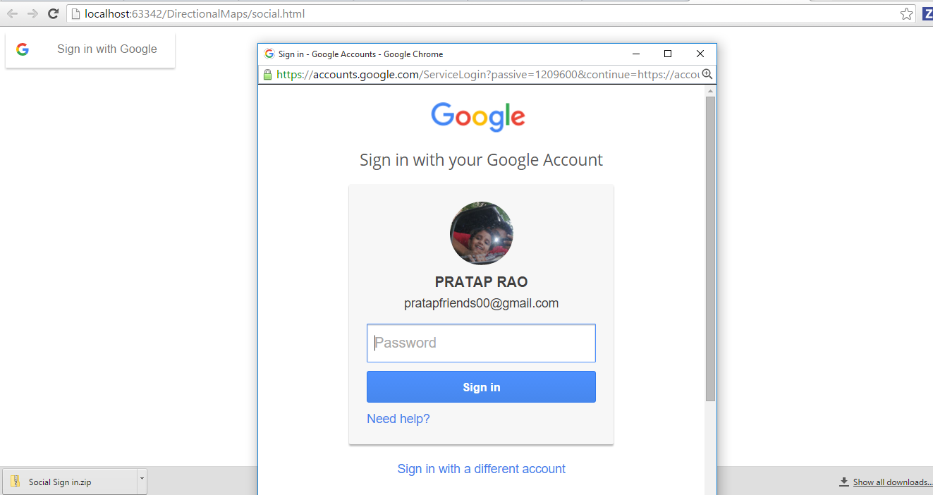

Here we have used API of flicker and open weather to get the weather of a particular place. With the help of the weather API we get the weather condition of a particular location. With the help of the flicker we get the background image. We have also added a process by which the weather temperature could be shown both in centigrade as well as F.

